**PROJECT 1:**

**Documentation of Project**

**Sprint Plan:** No of Sprint-1, Duration-21days.

1). Prepare a flow chart of the application and core concept, algorithm. Prepare separate git repository and update each and every work.

2). Create prototype application in Java (Add file, Delete File, Search File and Navigate to main menu.)

3). Verify/Test application functionalities and update it in git.

**Flow of the Application:**

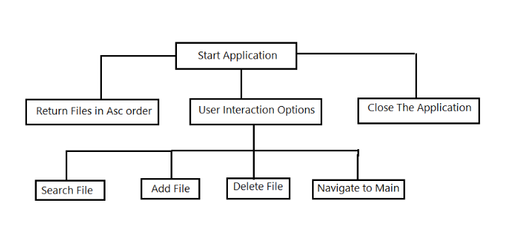

**Algorithm:**

1. Run the Application.
2. Select one of the Option 1 from the list which will Return existing files in Ascending order, User Interaction Option, Close the Application.
3. If Return Files in ascending order option selected then it Return all files in a dedicated path in Ascending Order.
4. Close the Application Option is user for getting out from the application.
5. User Interaction Options were Add new file, Delete existing file, Search file in dedicated path.
6. In Add File option we have to enter a file name with format (.txt,.doc,.) then it will create new file in dedicated path.
7. We can find a needed file using Search file option
8. As named like Navigate to main option is used for Navigate to main page.

**Instruction for work on Application:**

1.Click s to start else invalid input

2.After application starts enter input for perform the listed option

3.If 1(List out the Files name in Ascending order) entered it list out all file names in the allocated path

4.If 2(User Interaction Operations) entered it will list out all user interaction option like add file, delete file, search file and navigate to main option

5.Close the application option for exit from the application

6.In User Interaction Operations if we enter 1(Add file option) it will ask for enter a file name with format

7.After enter the file name it Create new file and return success message if file already exist it return a message file already exist

8.After a success message enter 'e' for exit from add file operation and 'c' for continue the operation again

9.If we enter 2(Delete file option) it will ask for enter a file name with format

10.After enter the file name it Delete file and return success message if file not found it return a message file not found

11. After a success message enter 'e' for exit from Delete file operation and 'c' for continue the operation again

12.If we enter 3(Search file option) it will ask for enter a file name with format

13.After enter the file name it Search a file in path and return success message if file found else it will return file not found message

14. After a success message enter 'e' for exit from Search file operation and 'c' for continue the operation again

15.Option 4 for Navigate to main page